1.program:

#include <stdio.h>

void function(int min);

int main()

{int n;

printf("Enter any positive integer:");

scanf("%d",&n);

function(n);

return 0;

}

void function(int n)

{

int count=0;

int i=1,s=1;

count++;

count++;

while(s<=n)

{

count++;

i++;

count++;

s+=i;

count++;

}count++;

printf("%d",count);

}

Output :

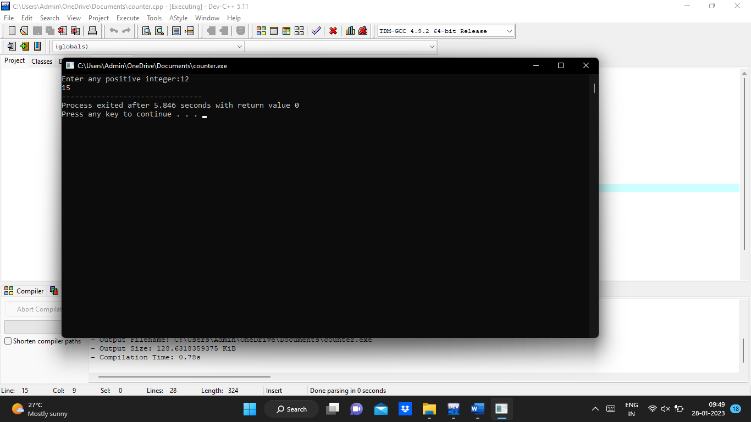

2.program:

#include <stdio.h>

void function(int n);

int main()

{

int n;

printf("Enter any positive integer:");

scanf("%d",&n);

function(n);

return 0;

}

void function(int n)

{

int count=0;

if(n==1)

{

count++;

count++;

}

else

{

count++;

for(int i=1;i<=n;i++)

{

count++;

for(int j=1;j<=n;j++)

{

count++;

count++;

count++;

count++;

break;

}

}count++;

}

printf("%d",count);

}

Output:

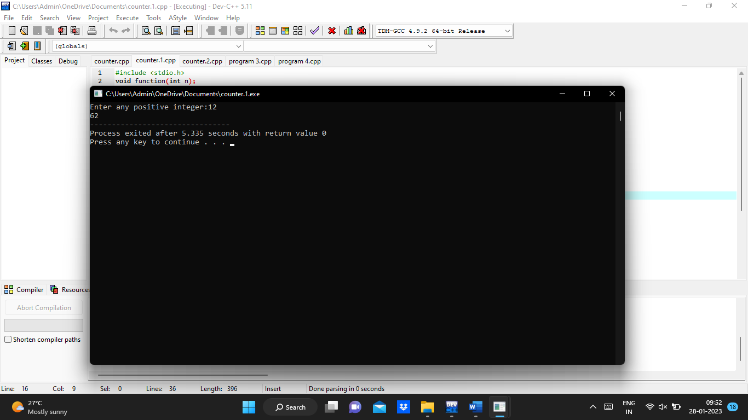

3.program:

#include <stdio.h>

int factor(int n);

int count=0;

int main()

{

int n;

printf("Enter any positive integer:");

scanf("%d",&n);

factor(n);

printf("%d",count);

return 0;

}

int factor(int n)

{

int i;

count++;

for(i=1;i<=n;++i)

{count++;

if(n%i==0)

{

}count++;

}count++;

return 0;

}

Output :

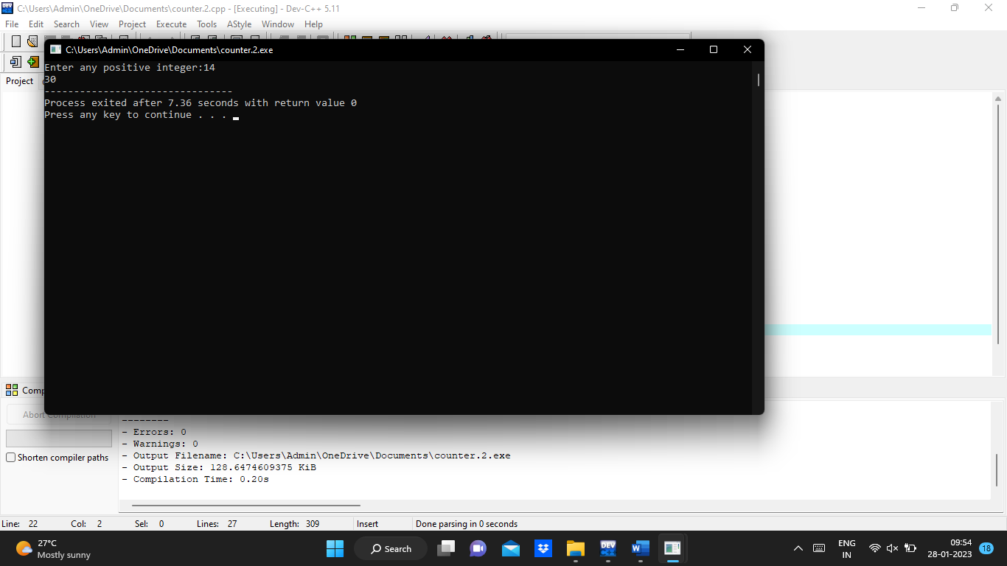

4.program:

#include <stdio.h>

void function(int n);

int main()

{

int n;

printf("Enter any positive integer:");

scanf("%d",&n);

function(n);

return 0;

}

void function(int n)

{

int count=0;

int c=0;

count++;

for(int i=n/2;i<n;i++)

{

count++;

for(int j=1;j<n;j=2\*j)

{

count++;

for(int k=1;k<n;k=k\*2)

{

count++;

c++;

count++;

}

count++;

}

count++;

}

count++;

printf("%d",count);

}

Output :

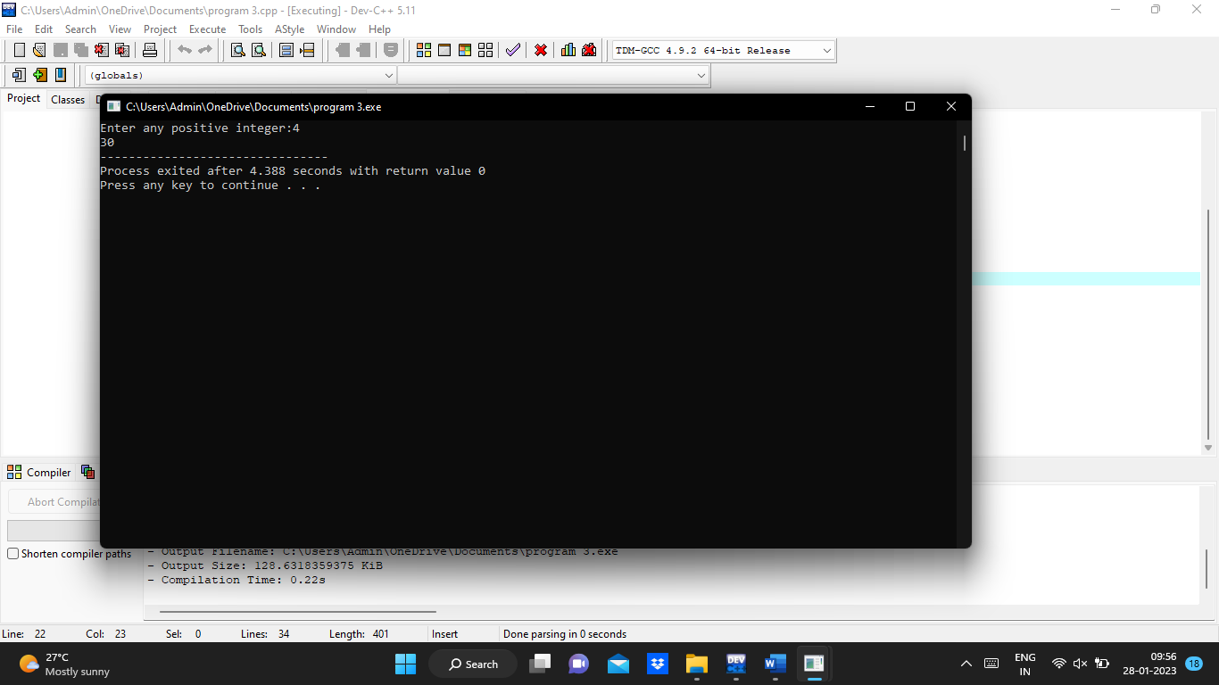

5.program:

#include<stdio.h>

void reverse(int n);

int main()

{int n;

printf("Enter any positive integer:");

scanf("%d",&n);

reverse(n);

return 0;

}void reverse(int n)

{

int count=0;

int rev=0,remainder;

count++;

while(n!=0)

{

count++;

remainder=n%10;

count++;

rev=rev\*10+remainder;

count++;

n=n/10; count++;

}

count++;

count++;

printf("%d",count);

}

Output :

